Designing Interactive Transparent Exhibition Cases

Juan David Hincapié-Ramos, Xiang Guo, Pourang Irani

University of Manitoba  
Winnipeg, MB, Canada  
{hincapjd, umguo62, irani}@cc.umanitoba.ca

**ABSTRACT**

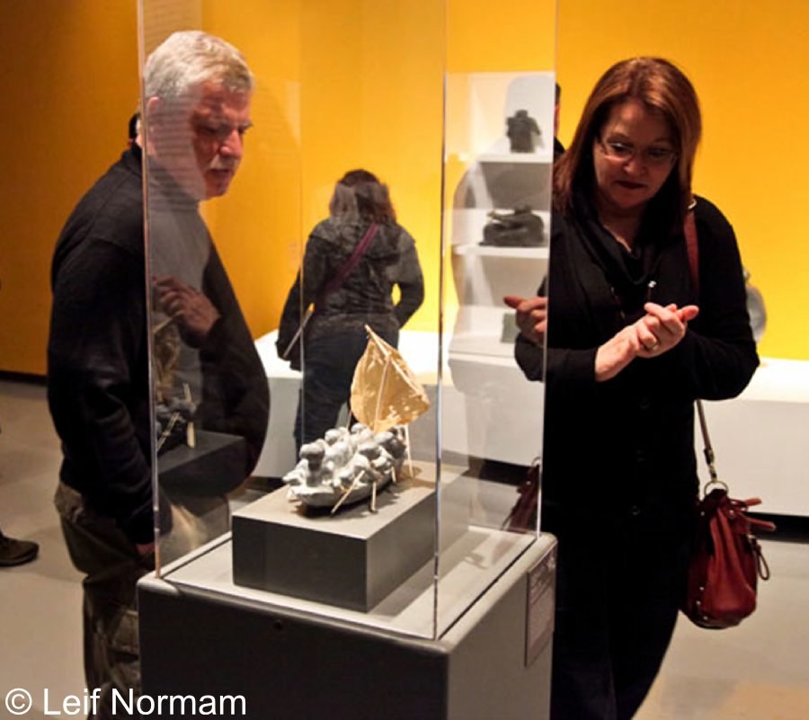

Figure 1: Traditional acrylic exhibition case (non-interactive).

Interactive technologies in museums enhance the visit experience by providing contextual information and fostering collaboration and participation. In this paper we revisit the design of the ubiquitous transparent exhibition case from a museum learning perspective. Transparent cases with interactive properties can complement other museum technologies and mitigate some of their shortcomings, such as the group isolation caused by audio guides and mobile devices. This paper focuses on the design of interactive cases and makes three contributions. First, based on field observations and interviews we present a list of requirements for interactive cases. Second, we propose a design space with dimensions grouped around the themes of *hardware*, *interaction* and *information* design. Our design space suggests interactive cases which present collocated information at increasing levels of detail, facilitate social interaction, and integrate with other technologies. Third, we demonstrate our design space through sample case designs and discuss the general technical challenges.

**Categories and Subject Descriptors**

H5.2 [Information interfaces and presentation]: User Interfaces. - Graphical user interfaces.

**Keywords**

Transparent Display, Cultural Heritage, Exhibition, Transparent Case, Case Display, Museum Display, Spatial Augmented Reality

# INTRODUCTION

Interactive technologies are transforming the experience of visiting museums and galleries [6]. Audio guides, mobile applications and public displays allow visitors to access relevant information on-site, to personalize it, and to collaborate with other visitors. These novel information and interaction opportunities redefine the traditional roles of museums; from institutions that deliver formal learning, to spaces that facilitate open-ended explorations and alternative interpretations of art and history [6].

Sharples [16] defined a set of goals for museum technologies including intuitiveness, unobtrusiveness and portability. However, field deployments show that current implementations, while fulfilling most of these design goals also present undesirable side effects. For example, audio guides isolate group individuals and hinder collaborative exploration, mobile applications divide visitor’s attention between the exhibition and the device, and public displays are spatially detached from the objects they augment and occupy prime exhibition space.

Recent advances in transparent displays allow us to envision their usage alongside current museum technologies, particularly as integral elements of exhibition cases. Exhibition cases are essential media for the showcase of volumetric artifacts which, unlike pictograms, afford exploration from multiple angles (see Figure 1). The glass/acrylic helps protect the artefact from visitors and environmental elements. Attached labels provide basic information. Augmenting exhibition cases with interactive capabilities can enable the provision of rich digital information while providing the necessary multi-angle viewing and protection. When used alongside other museum technologies, interactive cases can make information available directly “over” the artefacts, reach a wide audience and foster group dynamics; all without occupying extra space or having to carry a handheld device.

Permission to make digital or hard copies of all or part of this work for personal or classroom use is granted without fee provided that copies are not made or distributed for profit or commercial advantage and that copies bear this notice and the full citation on the first page. Copyrights for components of this work owned by others than ACM must be honored. Abstracting with credit is permitted. To copy otherwise, or republish, to post on servers or to redistribute to lists, requires prior specific permission and/or a fee. Request permissions from permissions@acm.org.

*PATCH 2014 @ IUI 2014*, February 24 2014, Haifa, Israel

Copyright 2014 ACM 000-0-0000-0000-0/00/00…$15.00.

http://dx.doi.org/00.0000/0000000.0000000

In this paper we explore the design challenges and opportunities involved in transforming exhibition cases into interactive media. First, we performed field observations in museums and galleries, and conducted interviews with relevant stakeholders. Based on our fieldwork we present a set of requirements for interactive cases including support for multi-side exploration, information scaffolding and open-ended exploration. Second, based on our own and others’ experiences designing museum and public display technologies, we propose a design space for interactive cases, and group its dimensions along the themes of *hardware*, *interaction* and *information* design. A design space is a conceptual tool that brings forth the different aspects to consider when designing interactive cases, making sure such designs meet the outlined requirements. Finally, we use our design space to design sample cases and discuss the most salient technical challenges involved in their implementation.

# RELATED WORK

The advent of tape recorded tours [16] and the Internet [6] marked the beginning of a new era for museums and galleries where information technologies complement the traditional ways of procuring information about exhibits such as books, leaflets and expert guides. Over the years, novel technologies have brought ever more promising results [6]. Digital audio guides allow visitors to navigate the audio contents interactively and in a non-sequential manner [14]. Mobile devices bring multi-media content to the hands of the visitor. Head-worn displays provide context-sensitive information based on user’s location and gaze. Public displays foster group engagement and collaboration.

More recently, researchers have started to explore augmented reality (AR) as an interaction paradigm for exhibition spaces. Mobile augmented reality, as used in [1], augments objects by simply pointing a handheld device at them. Spatial AR [2] uses fixed displays and projectors to augment objects. Although not mobile, projector-based spatial AR provides higher definition and can be experienced by multiple simultaneous visitors.

In this paper we depart from existing approaches to museum technologies (e.g. audio guides, mobile device, public displays), and investigate the re-design of an existing media. To the best of our knowledge, our work is the first to study exhibition cases as information appliances for museums. By redesigning existing exhibition cases, we expect to lower the entry barrier for visitors and, given their public nature, leverage their potential for social interaction. We go beyond proposing exhibition cases as devices for spatial AR (this is an alternative to the *content alignment* dimension ofour design space) and discuss issues such as *attention attraction* and *personalization*.

# ARTIFACTS ON DISPLAY

In order to understand the design and usage of transparent cases we conducted field observations at the Manitoba Museum[1] and the Winnipeg Art Gallery[2]. We analyzed the location, orientation and physical layout of exhibition cases, and performed artefact-centered observations of visits. We captured our observations in pictures, and later tagged them and grouped the tags into general themes. We also interviewed museum personnel including two curators and two administrators involved in installing exhibits. This section presents the results of our fieldwork and interviews as requirements for interactive cases; implicit is the requirement to protect and safeguard the exhibit artefact.

The first requirement for an interactive transparent exhibition case is *to support exploration from as many angles as needed* by the artefact (**R1**). For example, Figure 2A shows a case for simple objects “sufficiently” viewable if seen only from one direction. On the contrary, Figure 1 and Figure 2B show cases where the objects are rich in details from all viewing directions and angles. The required number of transparent sides and the size of the object influence the case location. Single-sided cases can be placed against a wall (Figure 2A). Small all-around cases can be in the middle of a room to facilitate exploration all around the artefact (Figure 1). Bigger cases can act as walls to separate different rooms (Figure 2B).

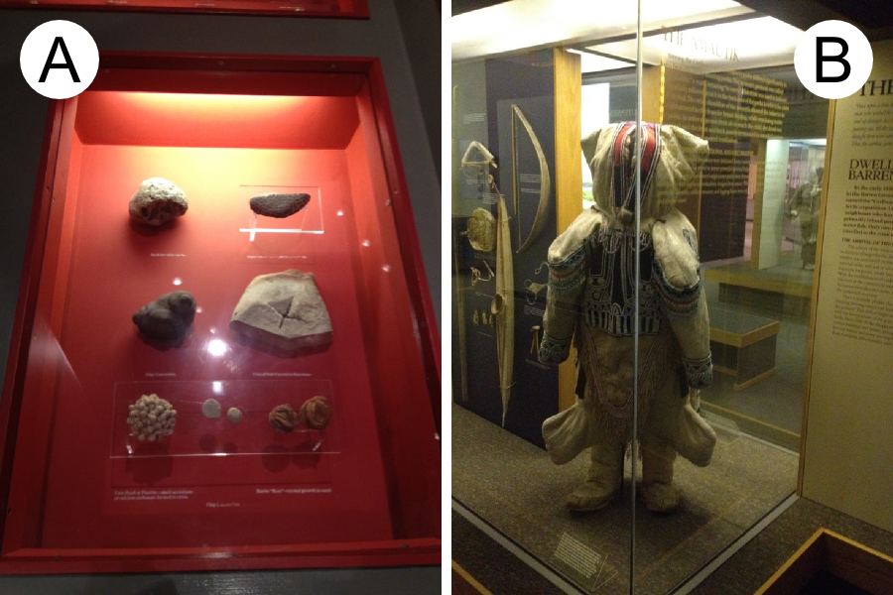

Figure 2: Planar and surround-see transparent cases.

The second requirement is *to link information to objects in accessible ways* (**R2**). Exhibition space is scarce and curators optimize it by grouping several objects in a single case (Figure 2A), and balancing the number of objects and information details. This tension is often resolved by using small labels which limit the amount of information delivered. More information is provided in the exhibition hand-outs or the didactic panels (Figure 2B-wall), however these elements are separated from the exhibit and are easily ignored (display blindness). Transparent cases can expand information either in size of content to facilitate access.

The third requirement, inspired by [16], is *to present information in unobtrusive and intuitive ways* (**R3**). Museums receive a wide range of visitors ranging from school pupils to older adults. Therefore, information should be provided in an accessible way for all audiences. This is evident in the current utilization of small labels and side panels which, as highlighted by the administrators, present a low entry barrier for the less tech-savvy visitors.

The fourth requirement is *to facilitate information scaffolding* around the notion of interpretation *layers* (**R4**). Interpretation layers connect the objects of an exhibition. One layer might be the thesis of the exhibition and connects all of its objects (e.g. the oral tradition of a tribal group). Another layer might be the works by a particular artist or material and connects only a subset of the objects within the collection. Layers might also reach beyond the local collection. While some of the visitors might not be interested in any particular layer (e.g. tourists), others might be interested in the general thesis and more specialized visitors might follow particular layers (e.g. an artist). Moreover, making layers explicit can provide context for the whole collection, even if other cases are not interactive.

The fifth requirement is *to support collaborative interaction* (**R5**). Transparent cases, similar to public displays, allow visitors to gather around an artefact and share interpretations. In a formal setting, visitors stand around the case and a guide indicates the points of interest of a given artefact. Informal groups move freely around the case, explore and point at the artefact, and create and share interpretations.

The final requirement is *to enable open-ended explorations* (**R6**). The static nature of current exhibition environments supports a learning experience where curators provide interpretations of the works (through static media such as fliers, labels and panels, and even through current technologies). Novel technologies should support museum visitors in creating and sharing their own alternative interpretations.

# DESIGNING INTERACTIVE CASES

Designing interactive cases to meet the outlined requirements can take many shapes. Moreover, previous works on museum [6] and public display [11] technologies suggest important issues which cannot be observed with non-interactive cases (e.g. attracting attention and motivating interaction). In this section we propose a design space for interactive cases (see Figure 3) that satisfies the six requirements presented above and the challenges listed in the literature. We group our design space dimensions around three themes: *hardware*, *interaction* and *information* design.

## Hardware Design

These dimensions define the physical design of the case. Note that hardware design also covers the provision of security, protection and environmental conditions [18].

*Transparent Display Technology* – Transparent see-through displays can be additive (e.g. projector-based or T-OLED) or subtractive (e.g. LCD). Projector-based displays use diffusive films or half mirrors, providing high levels of transparency, but requiring space for locating the projector. T-OLED displays are self-contained, but are the least transparent and have low color capacity [17]. LCD displays require a backlight and offer medium transparency; their usage should be limited to artefacts which can resist bright illumination. Selecting a display technology should consider the space availability, sufficient transparency to be unobtrusive (**R3**) and light resistance of the exhibit.

*Display Coverage* – This dimension refers to the percentage of the transparent surface which is a digital display. Given that displays cannot yet be made fully transparent, they blur objects. Moreover, interactive public displays are often “owned” by the active user, creating the honey pot effect [11] and keeping others from coming closer and exploring the object. In the case of single-sided cases (Figure 2A) proximity of the object to the display can minimize blurring. Exhibition cases that are larger or require more exploration sides can benefit from limited display coverage; this way, fully transparent areas (non-interactive) are available for clear and people-free exploration of the artefact (**R1**, **R3, R5**).

*Input Mechanism* – Depth cameras support natural (gestures, gaze tracking, virtual arms) or touch interfaces depending on their placement (front facing or parallel to the display respectively). IR cameras inside the box can support touch by means of FTIR or DI [15]. Camera-based and capacitive touch frames attached to the display require little space. Tangibles can serve as interaction surrogates to “select” content [7]. Finally, traditional input (e.g. keyboard, mouse, touchpads, trackballs, etc.) can support longer interactions and accommodate for less tech-savvy visitors (**R3**).

## Interaction Design

These dimensions define experience aspects of the case.

*Content Alignment* – The digital content showed by the display can be *aligned* or *plain*. *Aligned* content maintains a fixed real-world location from the user’s perspective (see spatial AR [1]). Aligned content changes its pixel location according to the relative locations of the user, the display and the exhibit. Although aligned content can optimize information linking (**R2, R3**), the content looks correctly aligned to only one observer at the time. *Plain* content maintains a fixed pixel location independent of the user location, thus making it easy to read from multiple angles (**R1**) and people (**R5**) simultaneously.

*Visitor Attraction* – Researchers showed that users often ignore the digital nature of displays in public spaces [11]. We expect this to be a problem also for interactive cases as users expect a non-interactive experience. Saliency (sudden changes in color or motion) captures users’ attention as it triggers our instinctive defense reflexes. Video, animations and random pulsations (from color, to black, to transparent) can run until a visitor touches the display or is detected by a tracking system. Proxemics can be used to estimate the visitors’ attention and adapt content accordingly [20]. Müller et al. [11] provide a more comprehensive discussion of attention in public displays.

*Communicate and Motivate Interaction* – Public displays are often expected to be non-interactive, a phenomenon called interaction blindness [13]. A simple solution is to invite visitors to interact via “touch me”-type of messages. More elaborate solutions include displaying the users’ silhouette and image [12], prompting users to “strike a pose” [19], or using “curiosity objects” [8]. Some of these methods also support open-ended interaction (e.g. playfulness of curiosity objects - **R6**). In any case, their design should be unobtrusive should the visitor wish not to interact (**R3**).

*Device Integration* – Interactive cases can operate as isolated devices (*solo*). Alternatively, interactive cases can integrate with devices in the same room (*local*), with devices all over the museum (*full-site*), and with online visitors and content (*online* – see [6]). Another option is to integrate with the visitor’s *mobile* devices and support interactions such as overview/details (**R4**) or content sharing and group coordination (**R5**).

## Information Design

These dimensions define what information is shown by the case.

*Information Object* – Interactive cases can provide information about the exhibit alone or can extend its reach to inform about other objects in the exhibition, other collections or the institution. Information can be provided along the information layers of an exhibit, by relating objects in the same layer (**R4**) or contrasting objects in different ones. How far a visitor can explore information layers impacts the storage architecture. For example, when exploring artefacts by the same artist, the interactive case can pull such information from the museum’s website. It also impacts the visit length and thus the perceived obtrusiveness (**R3**).

*Personalization* – Personalization refers to tailoring information to the visitor, providing the depth or breadth they expect. Interactive cases might ignore personalization and present a single navigation path with standard information. Another option is to support open exploration (manual filtering) by allowing users to click/activate content on demand (**R4**, **R6**). Users and content can also be classified into predefined types [4]; classification could be automatic, or started manually by the user or the visit host. Finally, adaptive user models can learn from past visitors to classify future ones and adjust content [9].

*Learning Approach* – The interactive case can be designed to support *formal* or *informal* learning processes. Formal learning is one-way, where curators create content (interpretation) and guide users through its exploration. On the other hand, support for informal learning allows users to freely explore and relate the information available in order to create and share alternative interpretations of the artefacts (**R6**).

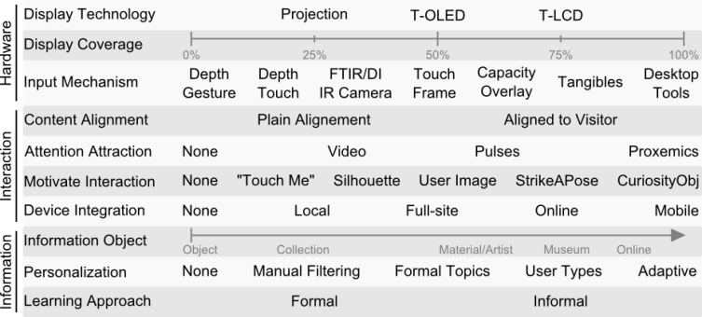

Figure 3: Design space for interactive exhibition cases.

# DESIGN EXPLORATION

Our ongoing work is the design of an interactive transparent exhibition case for the Winnipeg Art Gallery in their Inuit art collection. We demonstrate our design space by designing sample interactive cases for a small sculpture (similar to Figure 1). Based on these samples we discuss general implementation challenges.

Figure 4A shows a sample design based on a wooden top, a cylindrical acrylic surface and a rotating unit made up by a short-throw projector, a normal projector, and an infrared-camera. The acrylic surface rests on infrared LEDs embedded in the wooden top. Two areas of the acrylic surface are covered with a semi-transparent diffusive film (20% of the surface each). A transparent display is created by the short-throw projector on the film-covered areas. Proximity sensors on the side of the wooden top detect nearby users. When there are no users the top projector creates ambient animations. When a visitor comes to an interactive area the system rotates the top unit so that the short-throw projector creates a transparent display for the visitor with non-aligned content. The visitor interacts with information content via touch (FTIR with the infrared LEDs and camera). Icons afford the exploration of a topic (touch-me motivation, manual filtering). For example, touching the artist name shows a picture, biography and other works in the room (the information object is the current room). When a display is being used, the top projector provides other visitors with small labels on the wooden top. This sample design does not integrate with other devices.

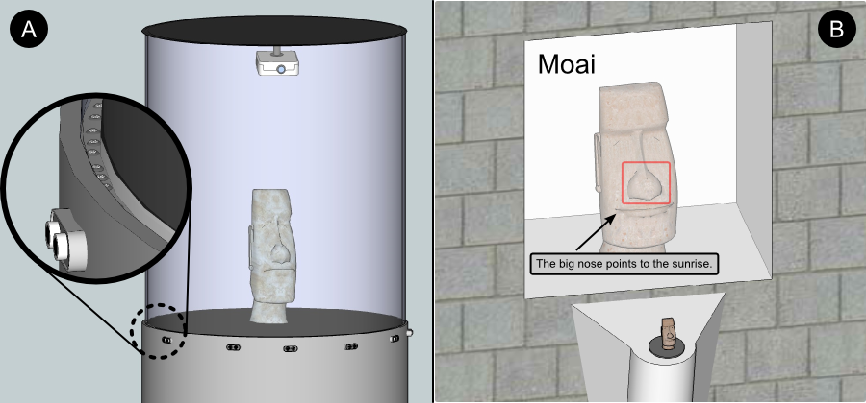

Figure 4: Two sample interactive exhibit cases that satisfy the six requirements. A) Cylindrical case, insert shows IR LEDs and ultrasound proximity sensors. B) Wall case, text is aligned.

Figure 4B shows a sample single-sided interactive case embedded into a wall. The system uses a transparent LCD on the complete transparent side and a depth sensor for skeleton and gaze tracking. A touch-enabled 3D-printed replica of the sculpture is placed in front of the display. With no visitors, an ambient animation is overlaid on the exhibit. Visitors are attracted by the ambient visualization or the 3D-printed replica (as a curiosity object). When the skeleton tracking system detects a visitor, the system displays basic object information aligned according to the user gaze. Visitors obtain more information by touching parts of the 3D-printed replica (manual filtering). A mobile application allows users to publish hand drawings to the display for a limited time (ephemeral graffiti) for informal and open-ended explorations.

Implementing these two designs poses technical challenges that are representative of interactive cases. The following examples illustrate the complexity of the implementation. First, the short projection distance of the cylindrical case requires key-stoning and image warping. While key-stoning is already present in some projectors, cylindrical image warping should be added to the graphics pipeline. Second, calibration is needed for FTIR touch on a cylindrical display, and for location tracking (gaze and skeleton) in relation to the display and the object. Third, localization and integration mechanisms are needed to pair cases and mobile devices. Finally, binocular parallax affects visualizations and requires novel selection [10] and highlighting components.

# CONCLUSIONS

The emergence of transparent display technologies shows promise for the re-design of existing museum cases as information appliances to support the museum visiting experience. We presented a set of requirements for interactive transparent exhibition cases. Based on these requirements, on reported experiences in the museum and public display literature, and on our ongoing design efforts, we presented a design space definition for interactive cases. Our design space shows that designing interactive cases goes beyond *hardware* issues, to include aspects such as *interaction* and *information* design. Finally, we presented sample case designs and discuss their implementation challenges.

# REFERENCES

1. ArtLens, Cleveland Museum Art. 2013. [Website] <http://www.clevelandart.org/gallery-one/artlens>
2. Bimber, O., Raskar, R., & Inami, M. 2005. Spatial augmented reality. Wellesley: AK Peters.
3. Brignull, H., & Rogers, Y. 2003. Enticing people to interact with large public displays in public spaces. In Proc. of INTERACT 2003.
4. Falk, J. H. 2009. Identity and the museum visitor experience. Left Coast Press.
5. Galligan, A. M. 1996. Tape recorded tours and the museum-going experience. The Journal of Arts Management, Law, and Society, 26(1), 7-15.
6. Hawkey, R. 2004. Learning with digital technologies in museums, science centres and galleries.
7. Hincapié-Ramos, J. D., Esbensen, M., and Kogutowska, M. 2011. Rapid Prototyping of Tangibles with a Capacitive Mouse. In Proc. DHRS2011.
8. Houben S. and Weichel, C. 2013. Overcoming interaction blindness through curiosity objects. In CHI EA '13. ACM.
9. Kuflik, T., Boger, Z., and Zancanaro, M. 2012. Analysis and Prediction of Museum Visitors’ Behavioral Pattern Types. In Ubiquitous Display Environments (pp. 161-176). Springer.
10. Lee, J.H. and Bae, S.H. 2013. Binocular cursor: enabling selection on transparent displays troubled by binocular parallax. In Proc. CHI '13. ACM.
11. Müller, J., Alt, F., Michelis, D., and Schmidt, A. 2010. Requirements and design space for interactive public displays. In Proc. MM'10. ACM.
12. Müller, J., Walter, R., Bailly, G., Nischt, M., & Alt, F. 2012. Looking glass: a field study on noticing interactivity of a shop window. In Proc. CHI '12. ACM.
13. Ojala, T., and Kostakos, V. 2012. Multipurpose interactive public displays in the wild: Three years later. Computer.
14. Proctor, N., & Tellis, C. 2003. The State of the Art in Museum Handhelds in 2003.
15. Schöning, J., Hook, J., Bartindale, T., Schmidt, D., Oliver, P., Echtler, F., Motamedi, N., Brandl, P., and von Zadow, U. 2010. Building interactive multi-touch surfaces. In Tabletops-Horizontal Interactive Displays. Springer London.
16. Sharples, M. (2000). The design of personal mobile tech-nologies for lifelong learning. Computers&Education, 34 (3).
17. Sridharan, S.K., Hincapié-Ramos, J.D., Flatla, D., and Irani, P. 2013. Color correction for optical see-through displays using display color profiles. In Proc. VRST '13. ACM.
18. Thomson, G. (1977). Stabilization of RH in exhibition cases: Hygrometric half-time. Studies in Conservation.
19. Walter, R., Bailly, G., and Müller, J. 2013. StrikeAPose: revealing mid-air gestures on public displays. In Proc. CHI'13. ACM.
20. Wang, M., Boring, S., and Greenberg, S. 2012. Proxemic peddler: a public advertising display that captures and preserves the attention of a passerby. In Proc. Pervasive Displays 2012. ACM.

Columns on Last Page Should Be Made As Close As Possible to Equal Length

1. The Manitoba Museum – <http://www.manitobamuseum.ca/>
2. WAG | Winnipeg Art Gallery – <http://wag.ca/>